The Continued Damages to our Children
  - New CDC statistics, the UK and public policy, OH MY!
To:fchase@gmail.com
From: Robert W Malone MD, MS
Date: Sep 7, 2022

The Continued Damages to our Children Video (Ends at 4min 25sec.)

In December of 2021, I made what I like to refer to as “my hostage video.”. Most of you have probably seen it already, but it is embedded at the top of this Substack. I call this video that - because I basically pleaded with parents to be careful about vaccinating their children (and because I am not very good with reading things on camera). That video has proven to be prescient. My hope is that I managed to influence at least a few parents to think twice before injecting their children.
But here we go again.
With all of the new press and government advocacy for the re-engineered “booster” shots that include both Wuhan-1 and BA-4/5 spike protein coding sequences, I decided to run a Pubmed search to discover what new research has been published on COVID-19 vaccines and children. I turns out to be a daunting tasks, as so much has been learned since I recorded that prescient viral video. There are now literally hundreds of articles on parental vaccine hesitancy and how to overcome it, and these have clogged the arteries of the scientific literature pipeline. Pubmed searches have become really difficult, because the noise related to the approved narrative has “flooded the information battlefield”. I don’t have to wonder too hard about the “who” that is funding all these vaccine “hesitancy” studies. IMO, these studies clearly show an effort by governments to fund their way out of COVID-19 “vaccine” hesitancy of parents all over the world. And if that was not enough of a problem for the vaccine pushers, now we have even the UK (British) government saying “no thank you” to COVID-19 genetic vaccines for children. For examples documenting this, please see here and here.
Good luck with that, COVID-19 genetic vaccine pushers. But this is also why we can’t stop researching, writing and speaking about this. If we do, they will win.
The data are becoming overwhelming that jabbing kids is a bad idea, just as I had warned last December. The majority of parents in the USA are coming to this decision everyday. Only 7% of parents have jabbed their children ages 6 months-4 years with a single dose or more as of August 31, 2022.
I take this to mean that we are winning the “war”, or at least this particular skirmish. Long ago Jill and I decided that trying to prevent the widespread deployment and mandating of these genetic COVID vaccines with children was “the hill that we would die on” (metaphorically). Most parents are drawing their own “line in the sand” at injecting their young children with an experimental “vaccine” that has a pretty sketchy safety profile and an upside down risk/benefit ratio. An injection for a disease for which healthy, normal children are at a very low risk for disease, let along death!
So, let's look at some of the new data:

In the UK, vaccinating children under the age of 12 years old has stopped, except for children in high risk categories. As per the “Green Book - guidance found on page 25, Sept 4, 2022 edition.
“The Green Book is guidance issued by HM Treasury on how to appraise policies, programmes and projects. It also provides guidance on the design and use of monitoring and evaluation before, during and after implementation.”
Subject to further clarification, on-going eligibility in 2022/23, after the one off-programme, is expected to be for children in the academic years where children are aged 11 or 12 years

Then we have the CDC’s own slide deck from their ACIP meeting - Sept 1, 2022. It is stunning.
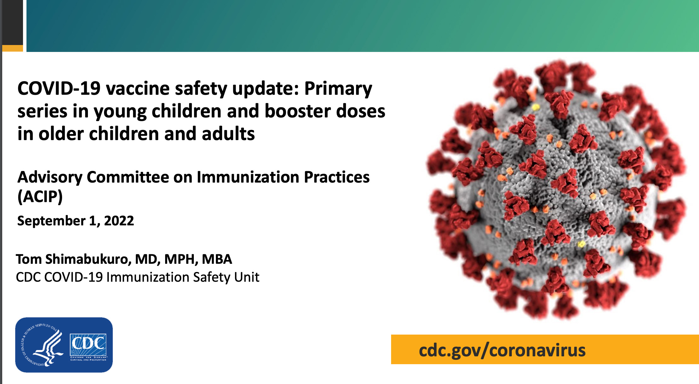
The interim analysis (incomplete reporting) of vaccinating toddlers and young children show that the VAERS data has 19 serious adverse events, which include “one of the following: death, life-threatening illness, hospitalization or prolongation of hospitalization, permanent disability, congenital anomaly or birth defect.”
Now, I bet that there aren’t that many adverse events from Omicron in the same time period in healthy normal children ages 6 months to five years.
Because Omicron is a very mild infection in the vast majority of children!

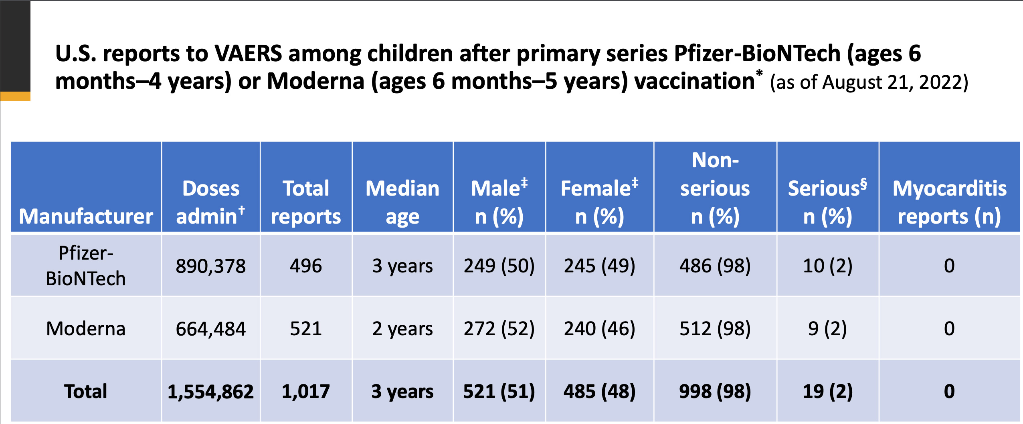
Then the CDC switches to their new V-safe monitoring system. And things get really worrisome. Upsetting. No, in this case, if you get very angry it is an appropriate reaction. I really do not like to promote rage, but I can understand why some might react that way when reviewing these data. Remember, many children were forced to take these products due to school mandates promoted by local school boards and the NEA teachers union.

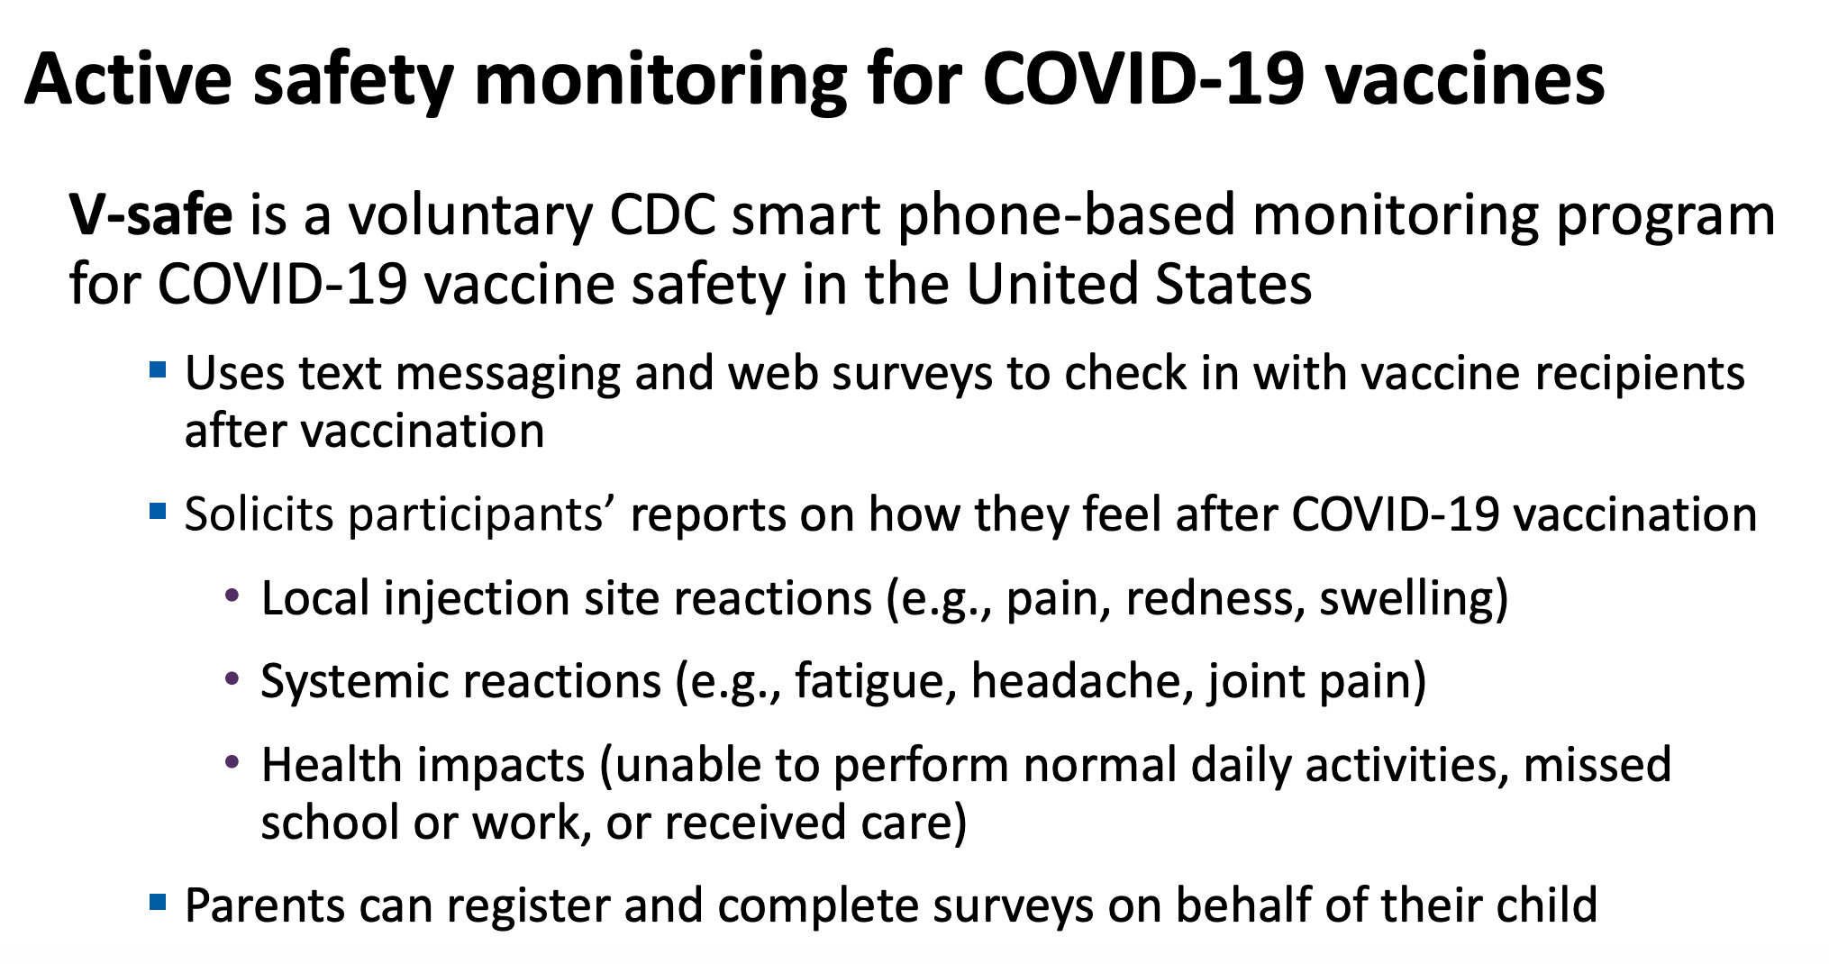

Between 50-60% of all babies and young children (see graphs below) reported a systemic reaction and about 10% had a “health impact.” Frankly, I find this shocking.

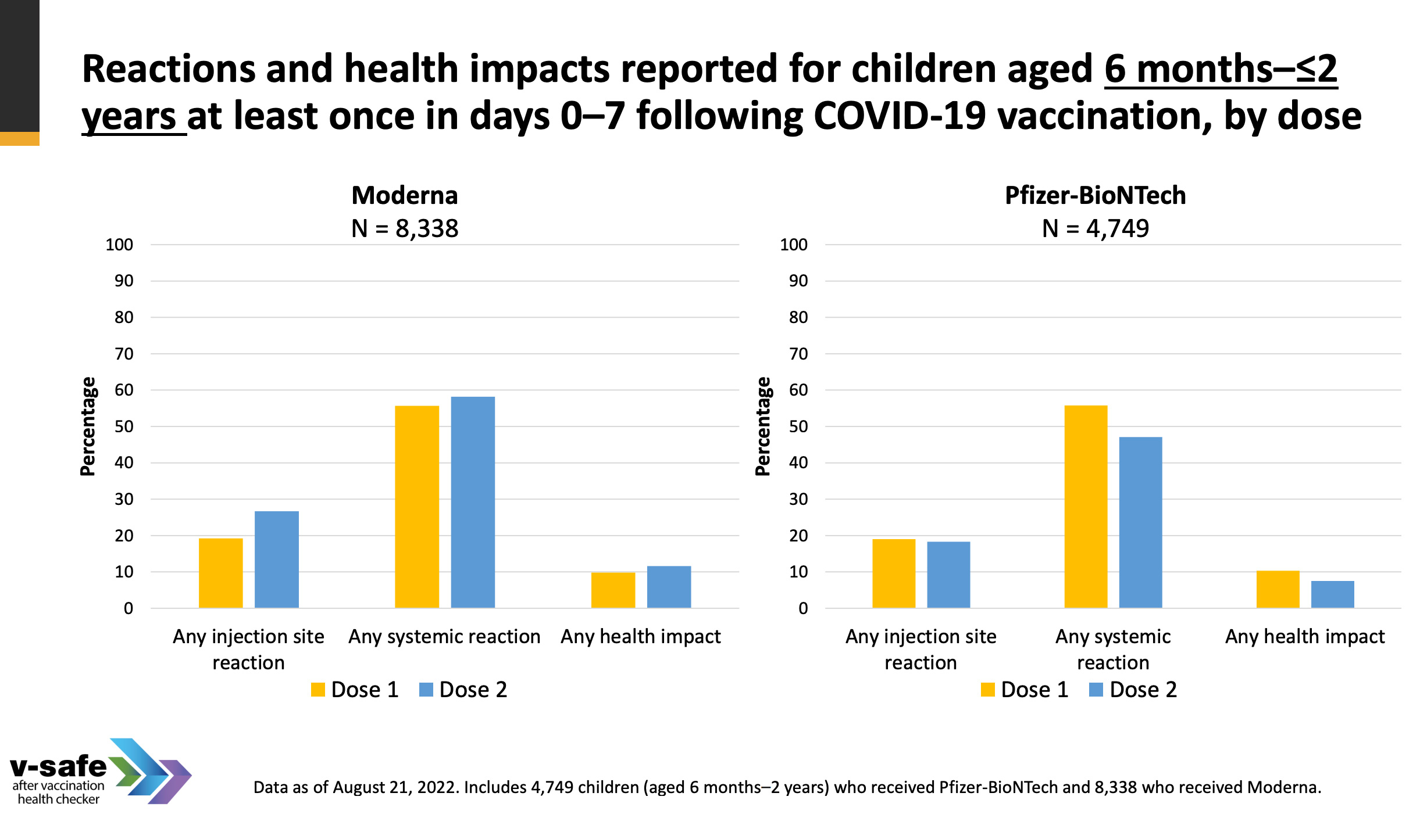

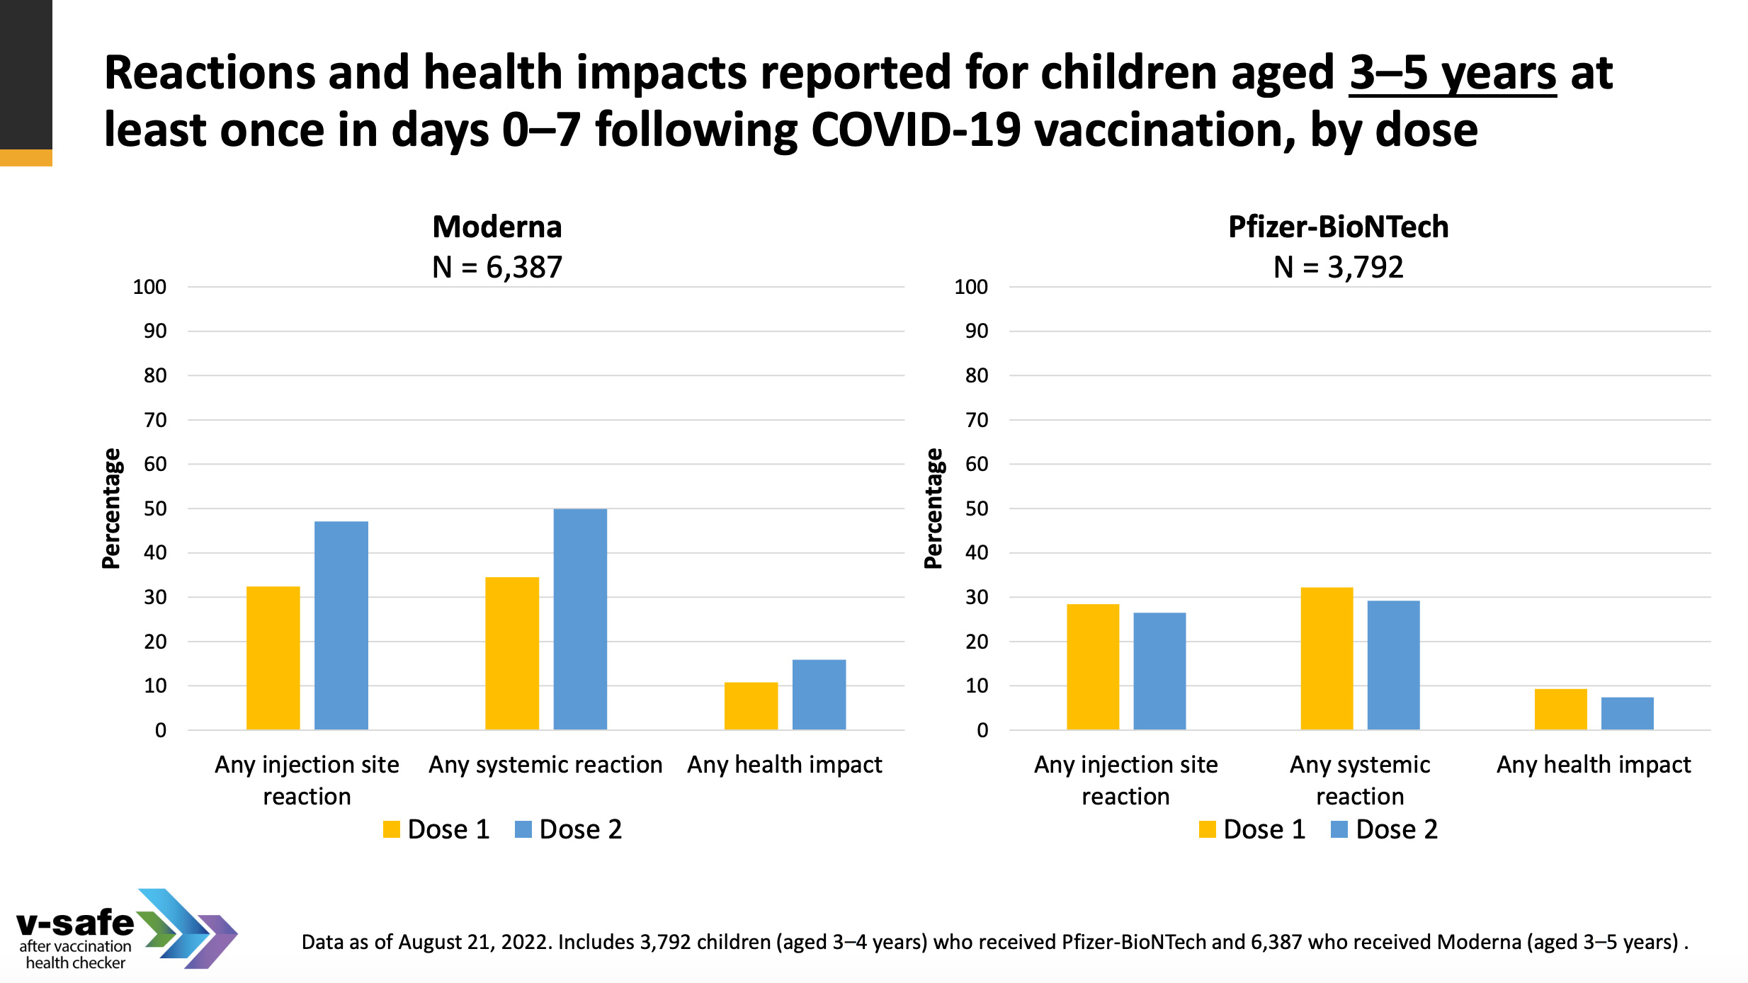

Remember that most Omicron cases in children are ASYMPTOMATIC! Children are at least 75% Asymptomatic for Omicron, such as shown in this study For the 26% of children that are symptomatic, those symptoms are very mild in healthy children. Then remember that almost all children have immunity to Omicron at this point. So, fewer and fewer are either exposed or contract the virus.
More OFFICIAL DATA from CDC VAERS and V-safe (monitoring system marked on the slides) are summarized below. And yet our government stands by and does nothing, which the UK government is stopping the jabbing of children so abruptly that Karens across the UK are complaining that they cannot get a second dose for their unfortunate young offspring.

Reviewing more data from the CDC slide deck:
Below: 40-50% of 5-11 years of age children have a systemic reaction and between 10-15% have a “health impact” after vaccination. Not only that, about 2-4% need “medical care.” For a vaccine against Omicron! A mild infection in children!
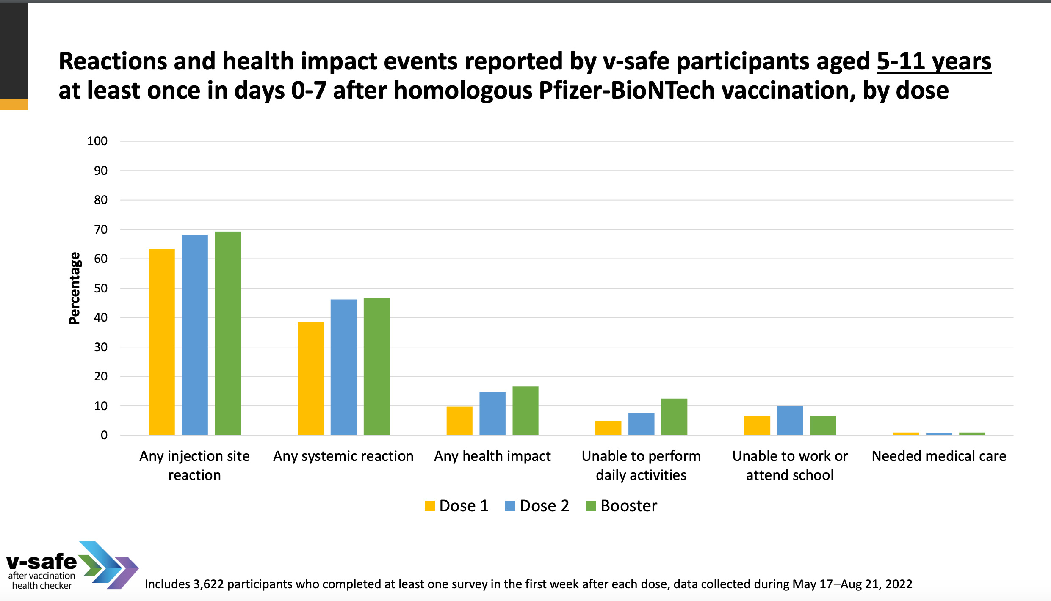

Below: 60-70% of 12-17 years of age children have a systemic reaction, with about 5 (1st vaccine) to 28% (booster) being unable to work or attend school after vaccination! Over 30% of children in this age cohort had a health impact for the second and booster dost. About 2% needed medical care! This is much higher incidence of vaccine related disease than that actual disease!
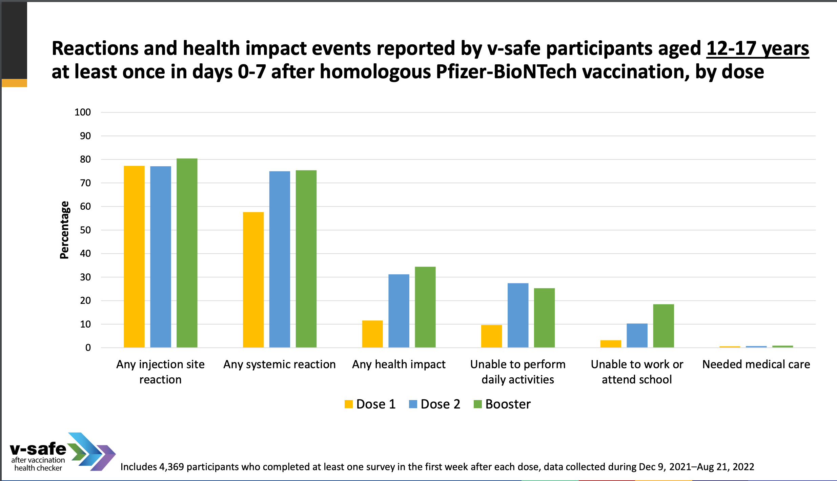

Then the CDC switches to the VSD monitoring system - which is a private insurance based system (passive monitoring of hospital records). For young men, aged 16-17 years of age - 1 in 5900 have myocarditis or pericarditis overall.
The VAERS and V-safe data from the CDC slide deck show a significant risk of myocarditis and pericarditis for young men, as has been reported elsewhere. Please go to the CDC slide deck to view all of those slides.
BUT - This is a biased analysis because it assumes that cases 22-42 post vaccination are not related to the vaccine! Even still the p-values are significant for young men in almost all categories. For women, they discount the cases in the 22-42 day range, which drops the p-values and the number of cases. As the mRNA is stable and still producing protein, we know that these cases should have been included in the analysis for both men and women, but are not.
In the CDC notes, it is mentioned that not all cases were included in this analysis due to reporting issues.

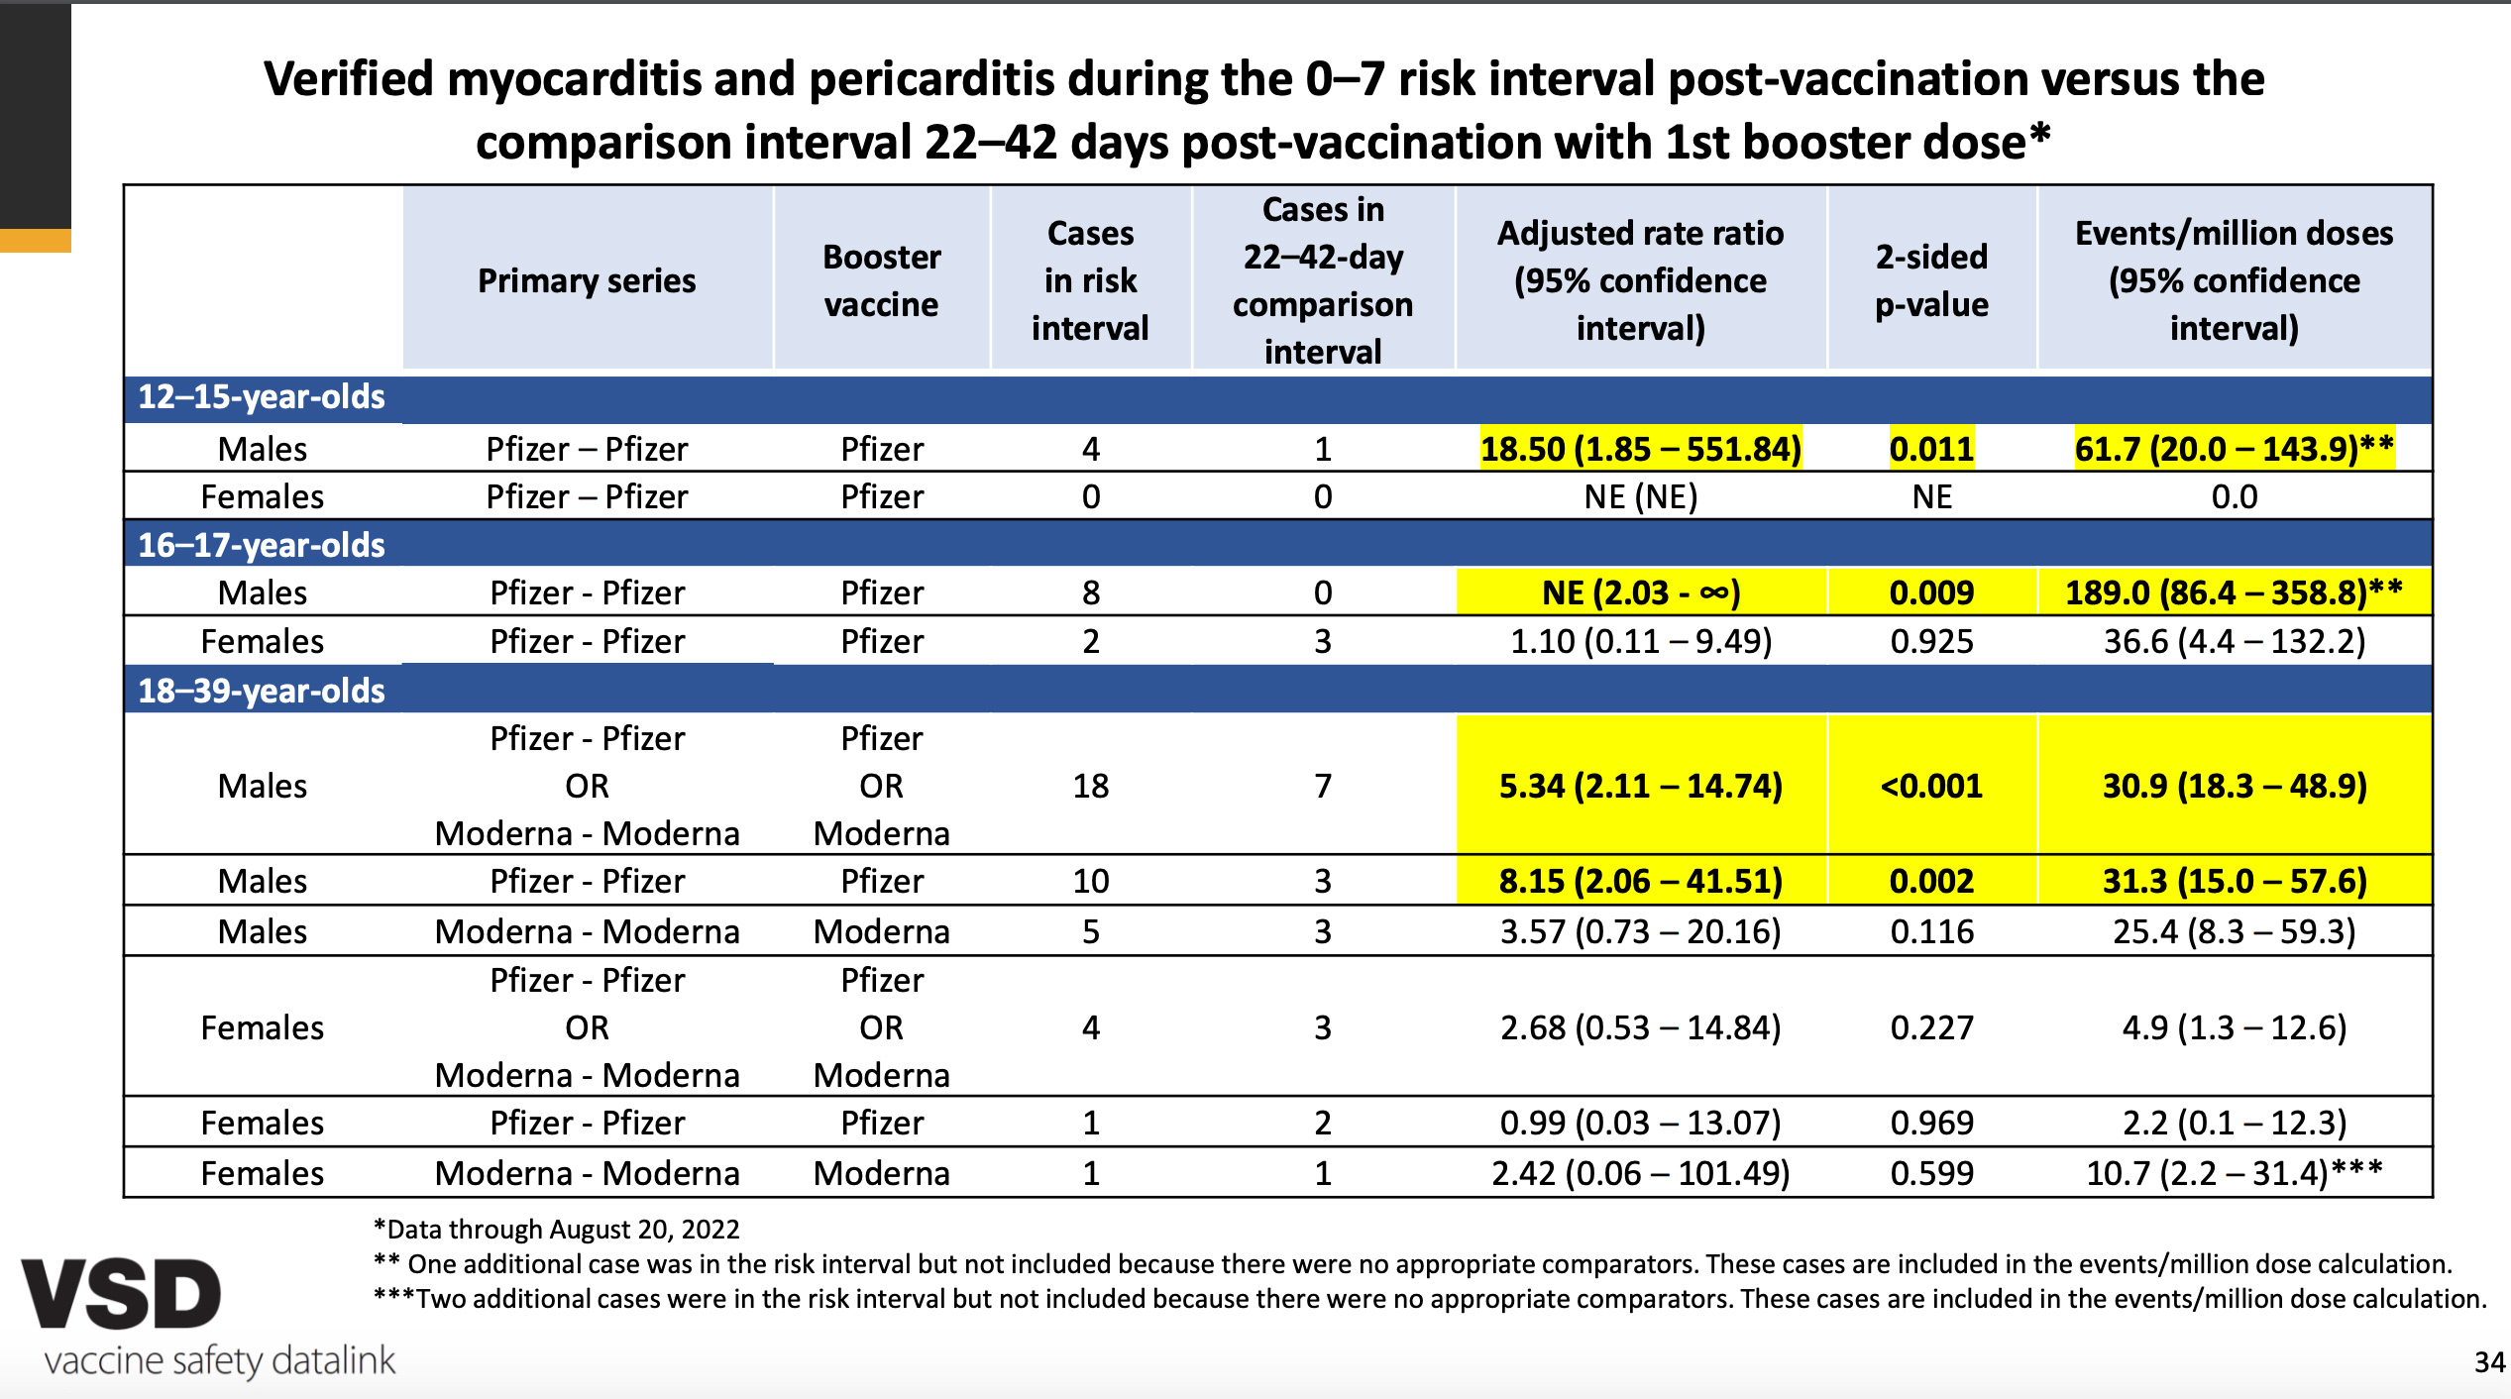

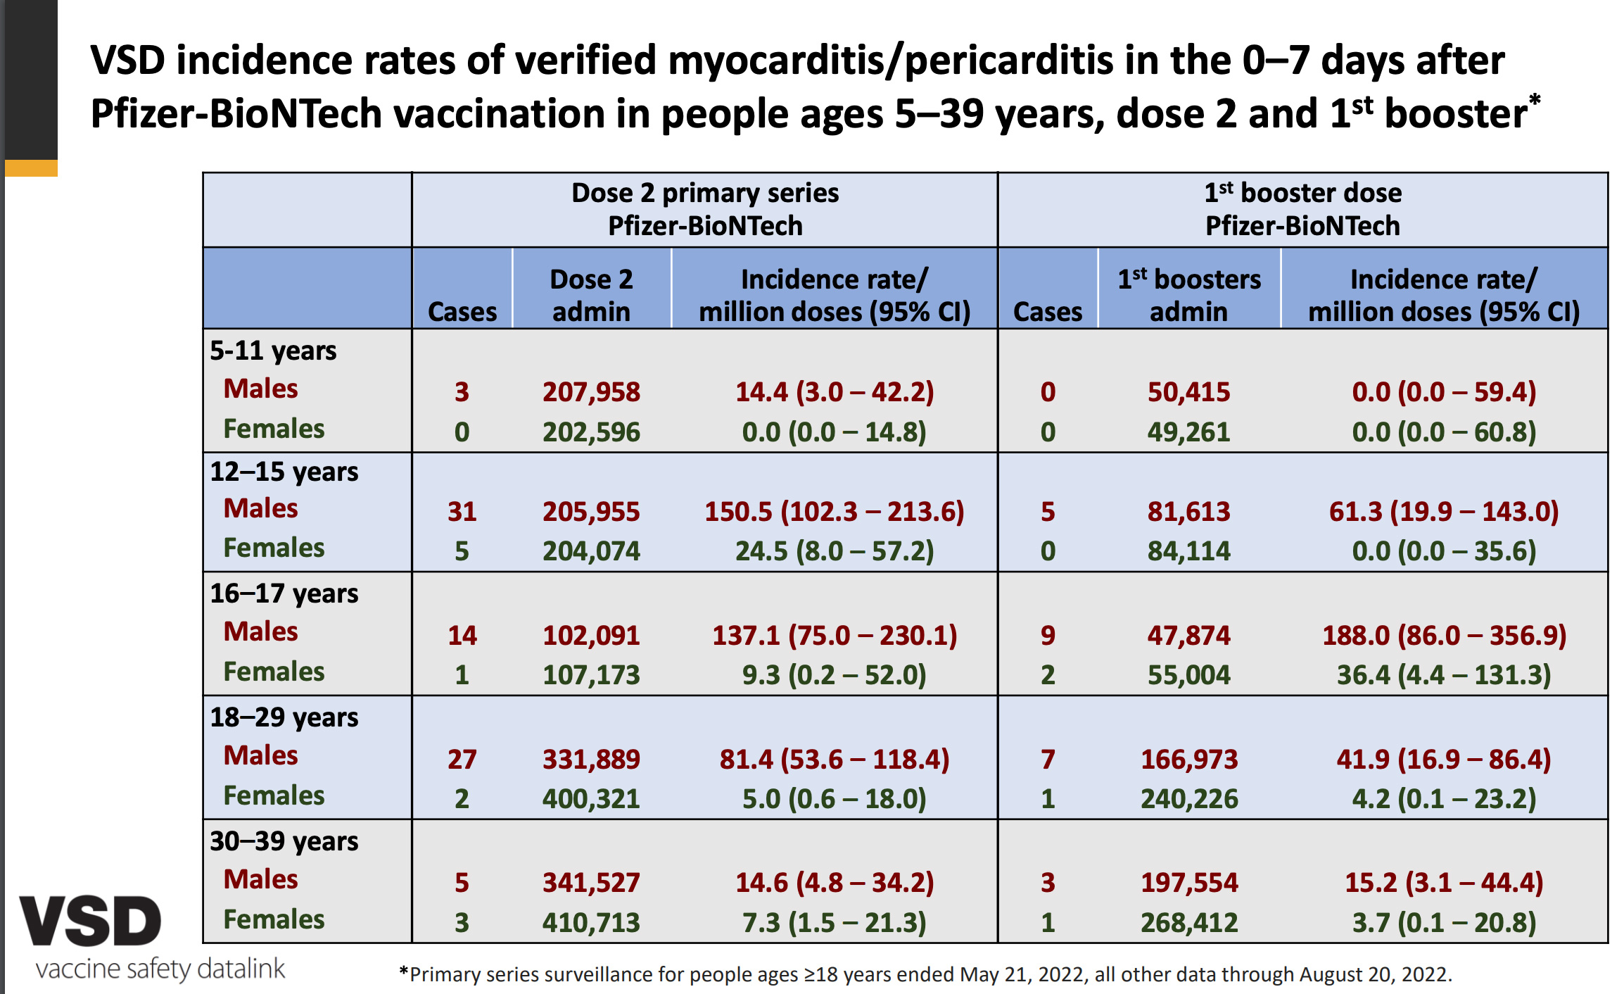

Please go to the CDC slide deck and review it for yourself. There is lots of data there. My friends who attended the ACIP meeting where this data was presented, said that ACIP members who asked questions were ignored and answers were not forthcoming. They were blown-off. The full ACIP meeting, minus the questions can be viewed here.
The CDC data above clearly shows that these vaccines are not safe for children and teens and should be discontinued immediately. The UK, Sweden, Poland, and many other nations have it right. They stopped vaccinating babies and children. Parents have it right. The vast majority aren’t vaccinating babies and children. It is time that the US government to face facts. It is time to stop vaccinating babies and children.
Beyond this - I urge parents… please think hard before you vaccine your child with these vaccines. The risks do not outweigh the benefits. Do not let yourself be coerced.

Personally, I am still waiting for that Twitter and Linked-in letter of apology! I suppose first the US Government would have to allow me to go back on social media platforms. Because we now know that the US governments control who and who is not allowed on Twitter and Linked-in. So, I don’t see myself being “re-platformed” any time soon, let alone receiving a letter of apology.
Defenestration is alive and well in the USA.

Thank you for reading Who is Robert Malone. This post is public so feel free to share it.
Share

Who is Robert Malone is a reader-supported publication. To receive new posts and support my work, consider becoming a free or paid subscriber.
Upgrade to paid

Give a gift subscription
Like | Comment | Share
You’re a free subscriber to Who is Robert Malone. For the full experience, become a paid subscriber.
Subscribe
© 2022 Robert W Malone, MD

